**LAB 09**

***EXERCISE 1:***

***Apply filter to the salt & pepper image using MATLAB Commands.***

m=imread("hassan.png");

m_noise = imnoise(m,'salt & pepper');

imshow(m_noise)

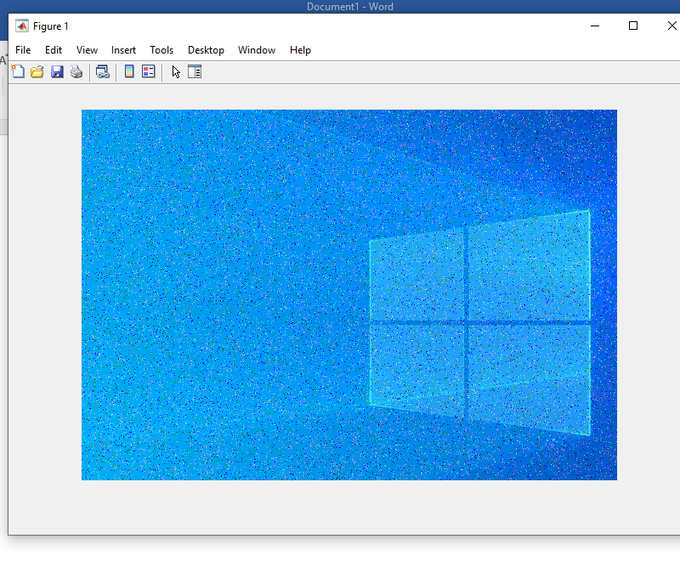

***EXERCISE 2:***

***Add Gaussian noise on grayscale image using MATLAB Commands.***

m=imread("hassan.png");

m2=rgb2gray(m);

m_noise = imnoise(m2,'gaussian');

imshow(m_noise);

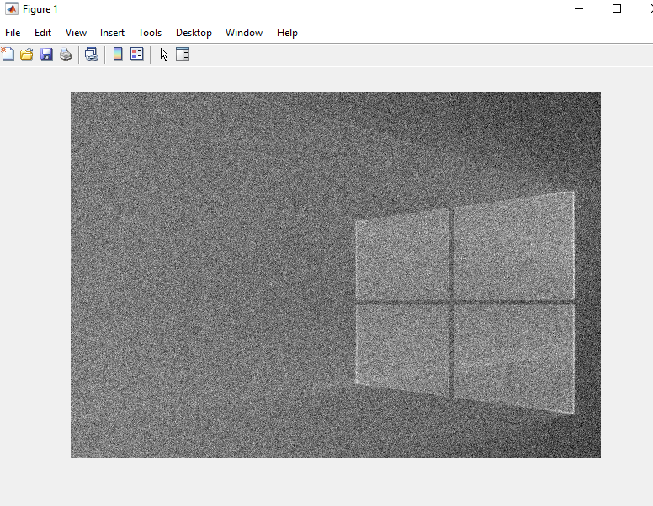

**EXERCISE 3:** **Apply filter to the Gaussian image using MATLAB Commands.**

m=imread("hassan.png");

m_noise = imnoise(m,'gaussian');

imshow(m_noise);

